ASSIGNMENT-2

Submitted by ADITYA SINGH 2K19/EP/005

% 1. Define the matrices and perform the following operations on the matrix A

T = [3 4; 1 8; -4 3] ;

A = [diag(-1:2:3) T; -4 4 1 2 1]

% a) extract a vector consisting of the 2nd and 4th elements of the 3rd row

a = A(3,[2,4])

% b) find the minimum of the 3rd column

b = min(A(:,3))

% c) find the maximum of the 2nd row

c = max(A(2,:))

% d) compute the sum of the 2nd column

d = sum(A(:,2))

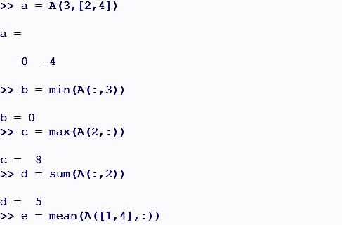

% e) compute the mean of the 1st and 4th rows

e = mean(A([1,4],:))

% f) extract the submatrix consisting of the 1st and 3rd rows and all columns

f = A([1,3],:)

% g) extract the submatrix consisting of the 1st and 2nd rows and the 3rd, 4th and 5th columns

g = A(1:2,3:5)

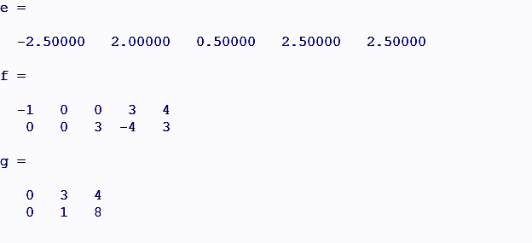

% h) compute the total sum of the 1st and 2nd rows

h = sum(A(1,:)) + sum(A(2,:))

% i) add 3 to all elements of the 2nd and 3rd columns

i = A(:,2:3) + 3

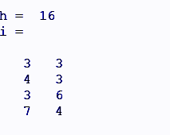

% 2. Determine which of the following statements can be correctly executed and provide the result

x = [1 3 7];

y = [2 4 2];

A = [3 1 6; 5 2 7];

B = [1 4; 7 8;2 2];

a = x+y

b = x+A

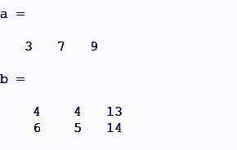

c = A - [x' y']

=> error : A is 2x3, [x' y'] is 3x2

d = [x;y] + A

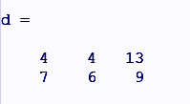

e = [x;y']

=> error: vertical dimensions mismatch (1x3 vs 3x1)

f = [x;y]

g = A-3

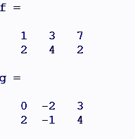

h = A+B

=> error: operator +: nonconformant arguments (op1 is 2x3, op2 is 3x2)

i = B'+A

j = B\*A

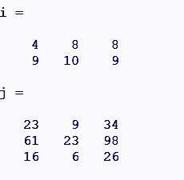

k = A'.\*B

l = 2\*B

m = 2.\*B

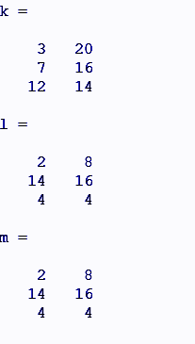

n = 2/A

=> error: operator /: nonconformant arguments (op1 is 1x1, op2 is 2x3)

o = ones(1,3)\*A

=> error: operator \*: nonconformant arguments (op1 is 1x3, op2 is 2x3)

% 3.Explain the results or perform the following commands

A = [2 7 9 7; 3 1 5 6; 8 1 2 5];

a = A'

b = A(1,:)

c = A(:,[14])

d = A([23], [31])

e = A(:)

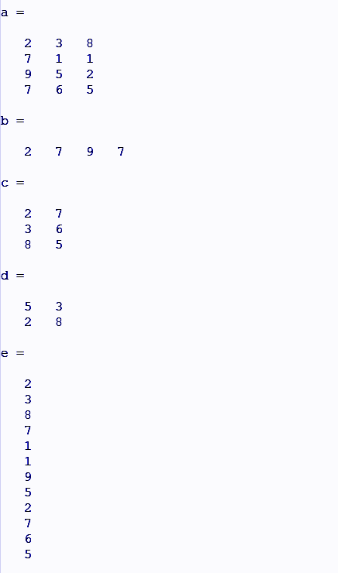

f = [A; A(1:2,:)]

g = sum (A)

h = sum (A')

i = mean (A)

j = mean (A'')

k = sum (A, 2)

l = min (A)

m = max (A')

n = min (A(:, 4))

o = max (min(A))

